**SPRINT 4:**

**Classification of Arrhythmia by Using Deep Learning With 2-D ECG**

**Spectral Image Representation**

|  |  |
| --- | --- |
| Date | 10 November 2022 |
| Team id | PNT2022TMID54282 |
| Project Name | Classification of arrhythmia by using deep learning with 2-d ecg spectral image representation |

**Code**: Updated in GitHub in the Deliverables section in Sprint 4 folder.

**Description of USN and Screenshots:**

**USN-6:**

As a user, I can upload an ECG image and view the result. The type of Arrhythmia such as Left Bundle Branch Block, Normal, Premature Atrial Contraction, Premature Ventricular Contractions, Right Bundle Branch Block and Ventricular Fibrillation is displayed.

**Screenshot:**

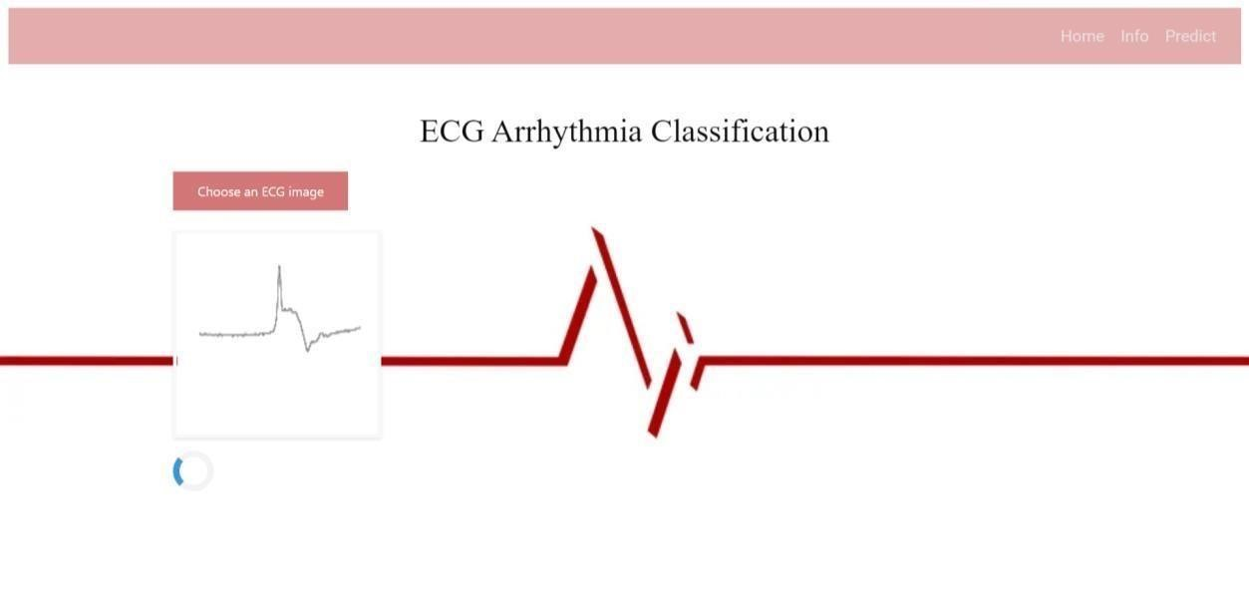

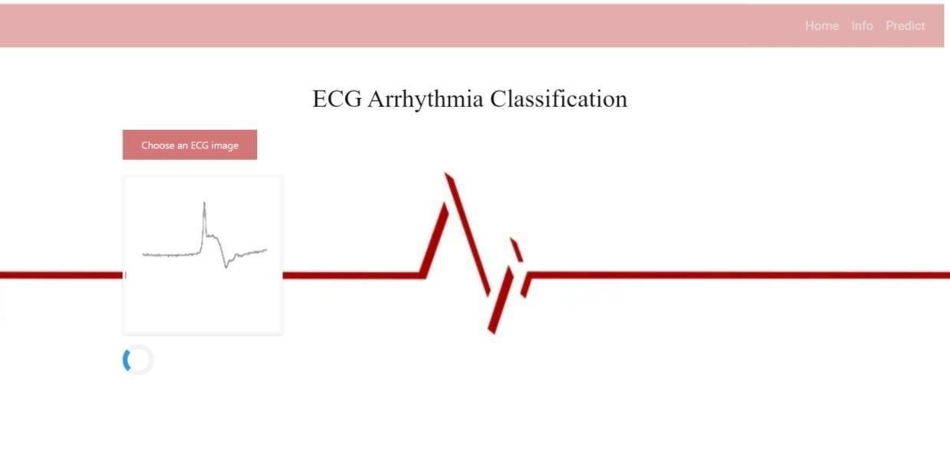

Result:



Premature Atrial



Contraction



**USN-7:**

As a user, I can upload any ECG image and view the result. The algorithm is designed to denote the type of Arrhythmia such as Left Bundle Branch Block, Normal, Premature Atrial Contraction, Premature Ventricular Contractions, Right Bundle Branch Block and Ventricular Fibrillation.

The HTML file used to build the Info page includes:

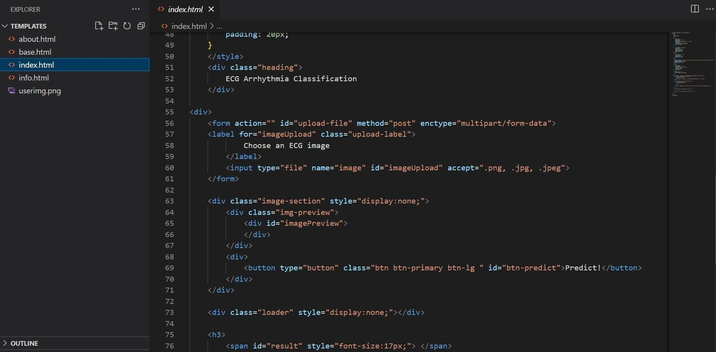

The Python code behind classification of Arrhythmia :

